MARKING KEY

0000.doc

PHYSICS
SECTION ONE: SHORT ANSWER

Question 1(a)
Heat vs. temperature
Description | Mark
Heat is thermal or internal energy being transferred because of a difference in temperature. | 1
Temperature is the average kinetic energy of the molecules that a substance is made of. | 1

Question 1(b)
Effects of heat
Description | Mark
NO | 1
Temperature rise is determined by 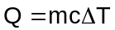 | 1
Both m and c differ in this case. | 1

Question 2
Kinetic energy
Description | Mark
E_{p} on roof = E_{k} at ground | 1
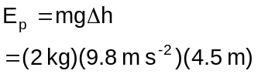 | 1
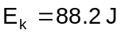. | 1

Question 3
Galaxy distance
Description | Mark
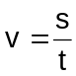 | 1
. | 1

Question 4
Lamps in a room
Description | Mark
All will be the correct brightness. | 1
If one fails, the others keep working. | 1

Question 5
Series resistors
Description | Mark
 | 1
Question 6
Nuclear equation
Description | Marks
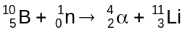 | 1

Question 7
Resistance calculation
Description | Mark
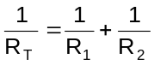 | 1
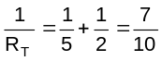 | 1
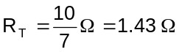. | 1

Question 8
Half-life
Description | Mark
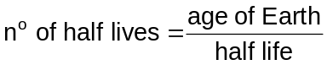. | 1
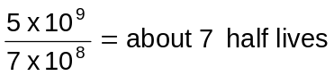. | 1

Question 9
Geiger counter
Description | Mark
Radiation spreads out from the source. | 1
Beta radiation is absorbed (attenuated) by air. | 1

Question 10(a)
Total energy radiated
Description | Mark
Energy radiated remains constant over one year  . | 1

Question 10(b)
Absorbed dose
Description | Mark
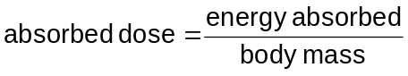. | 1
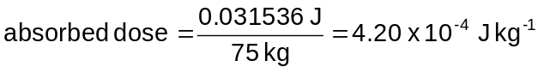 | 1

Question 11(a)
Volt definition
Description | Mark
Volt. | 1
The potential difference between two points is one volt if one joule of energy is needed to move one coulomb of charge from one point to the other. | 1

Question 11(b)
Emf calculation
Description | Mark
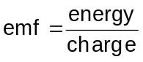 | 1
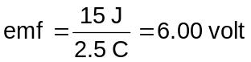. | 1

Question 12(a)
Reflective insulation
Description | Mark
Silver surfaces reflect emr well. | 1
This would insulate against radiant heat such as infrared. | 1

Question 12(b)
Batt-type insulation
Description | Mark
Glass is a poor thermal conductor | 1
The trapped air is also a poor thermal conductor | 1

Question 13(a)
Melting ice
Description | Mark
Must convert mass into kilograms m=0.360 kg | 1
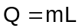 | 1
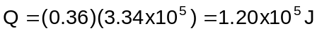 | 1

Question 13(b)
Energy transfer
Description | Mark
INTO | 1

Question 14
Hypothesis test
Description | Mark
B: Weighing the toast before and after it was on the plate. | 1

Question 15
Water heaters
Description | Mark
Heat spreads through water by convection | 1
Convection works best when the heat source is at the base of the convection cell. | 1

Question 16
Heating curve
Temperature (°C)
Energy added
0
100
Ice melts
Water heats up
Water boils

Description | Mark
Shape of graph | 1
Melting section smaller than boiling section | 1
Caption: Ice melts (or equivalent) | 1
Caption: Water heats up (or equivalent) | 1
Caption: Water boils (or equivalent) | 1

Question 17
Properties of radiation
 | ALPHA | BETA | GAMMA
Formula | 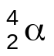 | 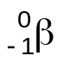 | 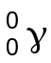
Ability to ionise matter | High | Moderate | Low
Ability to penetrate matter | Low | Moderate | High

Description | Mark
Formula of beta is 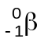 | 1
Ionising ability of gamma is low | 1
Penetrating ability of beta is moderate | 1
Penetrating ability of gamma is high | 1
Question 18
Write and balance a nuclear equation
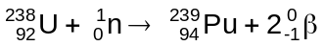

Description | Mark
Neutron included on left | 1
Betas shown as products on right | 1

Question 19
Density of water
Description | Mark
C: 277 K | 1

SECTION TWO: PROBLEM-SOLVING

Question 20(a)
Maximum height
Description | Mark
At max height, v = 0 | 1
If direction of u (upwards) is positive, then g (downwards) is negative. | 1
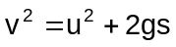 | 1
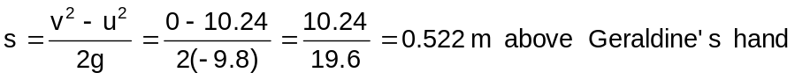. | 1

Question 20(b)
Final velocity
Description | Mark
 | 1
Since s = 0, v² = u² Thus, final velocity = 3.20 m s⁻¹ downwards. | 1

Question 20(c)
Momentum explained
Description | Mark
Momentum is the product of an object’s mass and its velocity. | 1

Question 20(d)
Momentum calculation
Description | Mark
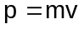. | 1
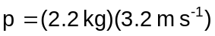 | 1
Momentum = 7.04 kg m s⁻¹. | 1
Direction is upwards. | 1

Question 21(a)
Power output
Description | Mark
 | 1
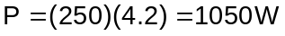 | 1

Question 21(b)
Energy transferred
Description | Mark
Must convert time taken = 10 minutes = 600 seconds | 1
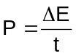 | 1
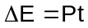 | 1
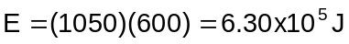 | 1

Question 21(c)
Temperature rise
Description | Mark
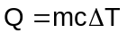 | 1
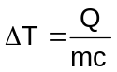 | 1
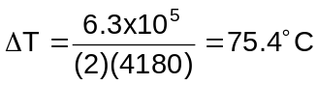 | 1

Question 22(a)
Velocity from graph
Description | Mark
12 m s⁻¹. | 1

Question 22(b)
Acceleration from graph
Description | Mark
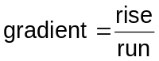 | 1
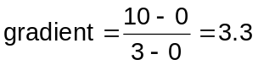 | 1
Acceleration is 3.3 m s⁻². | 1

Question 22(c)
Displacement from graph
Description | Mark
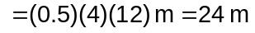 | 1
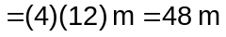 | 1
Total displacement = displacement (0 to 4s) + displacement (4 to 8s)  Total displacement = 24 m + 48 m = 72 m. | 1

Question 22(d)
Direction of travel
Description | Mark
No. | 1

Question 23(a)
Bequerel
Description | Mark
1.03 x 10¹⁵ Bq | 1

Question 23(b)(i)
Mass defect
Description | Mark
Difference between the mass of a nucleus and the masses of its components. | 1

Question 23(b)(ii)
Binding energy
Description | Mark
Energy released when the components of a nucleus come together; OR energy needed to break up a nucleus into its components. | 1

Question 23(b)(iii)
Relationship between mass defect and binding energy
Description | Mark
Binding energy is the potential energy decrease when the parts of a nucleus come together. | 1
Energy and mass are equivalent through the relationship 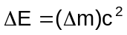. | 1
Mass therefore decreases when the potential energy of a nucleus decreases. | 1

Question 23(c)
Decay releases energy
Description | Mark
Mass LHS = 31.973 907 u | 1
Mass RHS = 31.972 071 + 0.000 549 u = 31.972 620 u | 1
Mass LHS > mass RHS. | 1
The ‘lost’ mass is replaced by energy. | 1

Question 24(a)
Weight of lift
Description | Mark
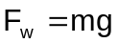 | 1
. | 1

Question 24(b)
Tension when moving at constant speed
Description | Mark
19.6 kN. | 1

Question 24(c)
Free body diagram—moving
Description | Mark
Upward force. | 1
Downward force. | 1
Same size (19.6 kN). | 1

Question 25(a)
Resistance of hot lamp
Description | Mark
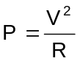 | 1
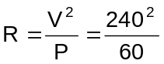 | 1
R = 960 Ω. | 1

Question 25(b)
Resistance of cold lamp
Description | Mark
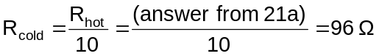. | 1

Question 25(c)
Ohmic vs non-ohmic conductors
Description | Mark
Resistance is constant in ohmic conductors. | 1
Resistance changes with current (or temperature) in non-ohmic conductors. | 1

Question 25(d)
Lamps
Description | Mark
No. | 1

Question 25(e)
Measuring resistance
Description | Mark
lamp  V  A | 1
Turn on and allow the lamp to heat up. | 1
Measure V and I. | 1
Use Ohm’s law to calculate resistance. | 1

SECTION THREE: Comprehension section

Question 26(a)
Variables
Description | Mark
They measured: thinking time OR braking distance. | 1
They controlled: [any two of] type of vehicle, daylight, condition of road, stimulus. | 2

Question 26(b)
Experimental design
Description | Mark
This would reduce the uncertainty in their measurements. | 1
By averaging out human errors by any one driver. | 1

Question 26(c)
Error reduction
Description | Mark
Having trials for each driver at each speed reduces possible errors/uncertainties. | 1
By allowing for people applying the brakes differently at different speeds (and so biasing the data). | 1

Question 26(d)(i)
Line of best fit
Mark | Description
1 | 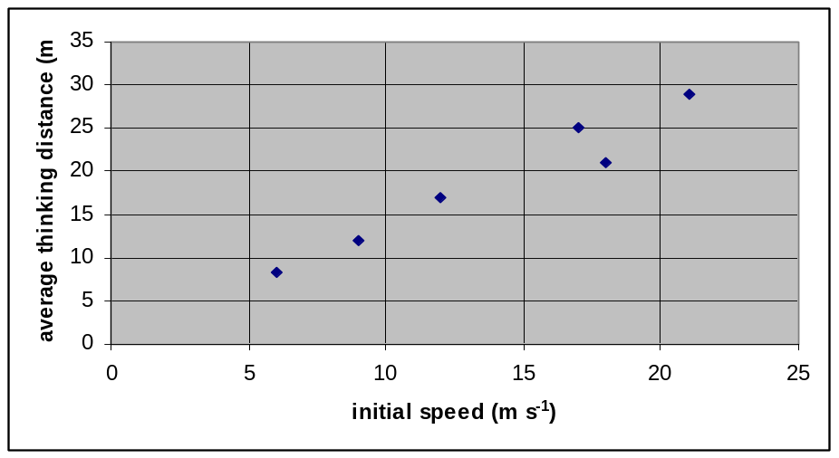

Question 26(d)(ii)
Thinking distance and initial speed
Description | Mark
Thinking distance increases regularly as the initial speed increases. | 1

Question 26(d)(iii)
Thinking distance from graph
Mark | Description
1 | About 20.5 m.
1

Question 26(e)
Conclusion
Description | Mark
The distance required to stop increases as the initial speed increases. | 1
The stopping distance increases faster than the initial speed increases. | 1
There would probably be fewer accidents if people drove more slowly. | 1

Physics Stage 2 exam

 | 2A |  |  |  | 2B
 | Working in physics | Motion and forces | Nuclear physics |  | Working in physics | Heating and cooling | Electrical fundamentals
SECT A
1 |  |  |  |  |  | X
2 |  | X
3 |  | X
4 |  |  |  |  |  |  | X
5 |  |  |  |  |  |  | X
6 |  |  | X
7 |  |  |  |  |  |  | X
8 |  |  | X
9 |  |  | X
10 |  |  | X
11 |  |  |  |  |  |  | X
12 |  |  |  |  |  | X
13 |  |  |  |  |  | X
14 |  |  |  |  | X | X
15 |  |  |  |  |  | X
16 |  |  |  |  | X | X
17 |  |  | X
18 |  |  | X
19 | X
SECT B
20 |  | X
21 |  |  |  |  |  | X
22 | X | X
23 |  |  | X | X
24 |  | X |  | X
25 |  |  |  | X |  |  | X
SECT C
26 | X | X

